Bluetooth-Controlled Glove with Flex Sensor

**Project Guide and Team Members**

**Project Guide**:  Dr. Richa Sharma

**Team Members:**

Abhishek Yadav

Sourav Sharma

Anuj

Basant Kumar

**Abstract**

Sign language is an important communication tool for people who are deaf or hard of hearing to interact in environments where speech is difficult. However, relying on sign language often limits accessibility because it requires understanding between the speaker and the receiver. The project addresses this gap by creating a wearable device that instantly translates hand gestures into spoken language, enabling greater communication and understanding. The system captures hand gestures using a Bluetooth-controlled glove equipped with a flexible sensor, accelerometer, and mobile app, and converts them into speech output. This solution not only allows people with hearing loss to communicate independently, but also allows sign language to be used in situations where direct speech is not possible, such as in noisy places, places where a quiet environment must be maintained, or remote meeting places. The program emphasizes the importance of communication technologies in promoting participation and developing the use of sign language in a variety of social and professional settings.

**INTRODUCTION**

**Background of project:**

The use of sign language is essential for people who have hearing or speech impairments to communicate with others. However, it can be challenging for those who do not understand sign language to communicate effectively with this community. An AI-based sign language system can solve this problem by converting sign language into spoken or written language [1]. According to the World Federation of the Deaf and World Health Organization Estimates, about 70 million people worldwide are deaf-mute and face communication difficulties because they cannot read or write in standard two languages [2]. Sign language is the mother tongue that the deaf and mute use to communicate with others. Sign language mainly relies on gestures to convey meaning, combining finger shapes, hand motions, and facial expressions , but the problem is the inability of the others to understand these languages, which act as a communication barrier. The person every time needs a translator for communication. With the aid of a lightweight Sign language recognition-based glove system fitted with sensors and an electronic circuit, this contact barrier can be overcome and used by both dumb and able people to learn Sign language. There are many different sign languages used throughout the world, each with its own unique grammar, vocabulary, and cultural significance. For example, American Sign Language (ASL) is widely used in the United States and Canada, while British Sign Language (BSL) is used in the United Kingdom. Sign languages have a long and rich history, with evidence of sign language use dating back to ancient civilizations. Communication can be defined as the act of transferring information from one place, person, or group to another . It consists of three components: the speaker, the message that is being communicated, and the listener. It can be considered successful only when whatever messages the speaker is trying to convey is received and understood by the listener. A lot of research has been done in this field and there is still a need for further research. For gesture translation, data gloves, motion capturing systems, or sensors have been used. Vision-based SLR systems have also been developed previously. **The existing Indian Sign Language Recognition system was developed using machine learning algorithms with MATLAB . They used two algorithms to train their system, K Nearest Neighbors Algorithm and Back Propagation Algorithm**. Their system achieved 93-96% accuracy. Though being highly accurate, it is not a real-time sign language recognition system.

**Statement of problem:**

During the study of this project, we acknowledged to various scenarios, where because of unavailability of sign language recognition system many deaf-dumb people face problem. Also it is a recognizable factor that people found themselves helpless. So by this project we are aimed to reduce the human efforts by making an accurate and affordable sign language recognition system.

**Aims and objectives of study:**

The main objective of this project is to design a sign language detection system using flex sensors. Other specific objectives are-

* To make a cost-effective system.
* To utilize smartphone as a way of translation.

**METHODOLOGY**

The methodology used in work is prototyping. The prototype is subdivided into many systems:  
circuit(flex sensor integration) , Arduino Uno system , HC-05 bluetooth system.The smart glove system translate analog signal from flex sensor into digital which is understood by Arduino uno . Hc-05 bluetooth module then connected to phone sends the signal received from Arduino Uno to smartphone which translate the messages coming from the gestures of hand.

**Output in form of voice**

**Output of HC-05 to smartphone**

Output

TTS Software

HC-05

Flex sensor

Power Supply

Arduino Uno

Fig: Block diagram of System.

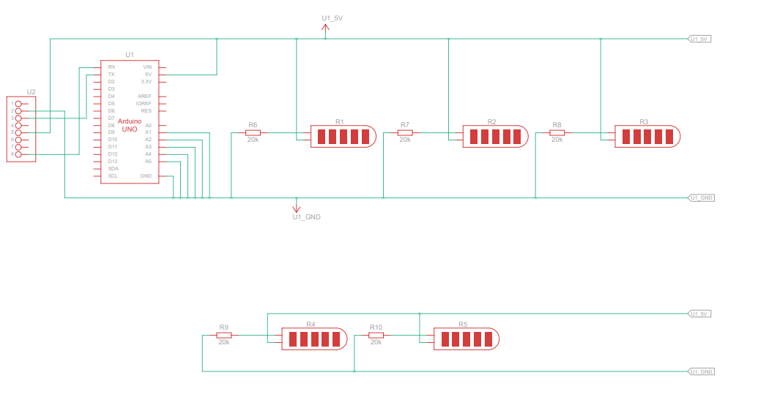

Fig: full circuit diagram of the circuit.

**Literature Review**

**Components used & Connections**

**Components Used:**

* Flex Sensor
* 20k ohm Resistor
* HC-05 Bluetooth Module
* Arduino Uno

**HC-05 Bluetooth Module:**

1. VCC: Connect to Arduino 5V
2. GND: Connect to Arduino GND
3. RX: Connect to Arduino RX (Pin 3)
4. TX: Connect to Arduino TX (Pin 2)

**Flex Sensor:**

1. **One End:** Connect to 5V
2. **Other End:** Connect to Analog and a 20kΩ resistor( making a voltage divider circuit )

**Apps used for Data receiving and transmission**

**Apps Used for Receiving Data on Mobile Phone:**

1. **Serial Bluetooth terminal:** [**Link of app**](https://play.google.com/store/apps/details?id=de.kai_morich.serial_bluetooth_terminal) **(used to receive text data from hc-**05 sensor)
2. **Arduino Bluetooth text to speech converter:** [**Link of app**](https://apkpure.com/arduino-bluetooth-text-to-spee/com.zaptha.bluetooth.bluetoothsensor) **(** used to translate the received text into voice  ).

**Alternate app used to receive data :**

1. **Macrodroid:** [**Link of app**](https://play.google.com/store/apps/details?id=com.arlosoft.macrodroid)**(** used for text to speech translation )
2. **Bluetooth serial monitor :** [**Link of app**](https://play.google.com/store/apps/details?id=com.arduinogetstarted.bleserialmonitor%20) **(**used to receive text data from hc-05 sensor )
3. **Specification of Flex sensor**

The flex sensor used in this project is capable of detecting bending angles. The sensor's resistance changes based on the amount of flex, allowing for angle-specific responses.

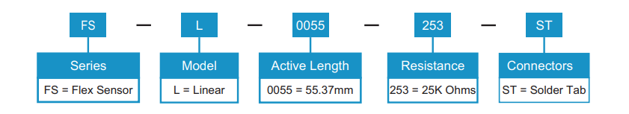

**Need/Uses of Project**

**Assistive Technology for Accessibility**:

* Many individuals with physical disabilities or speech impairments rely on alternative communication methods. This glove-based system can translate hand gestures into text or voice, acting as an assistive device that enables effective communication.

**VR/AR Applications**:

* Enables users to interact with virtual environments by translating physical gestures, making it valuable in gaming, simulations, and immersive VR experiences.

**Home Automation and IoT Control**:

* Gesture commands from the glove could be used to control connected devices in a smart home, such as turning on lights, adjusting the thermostat, or playing music.

**Conclusion**

In conclusion, the proposed system for sign language detection for deaf and dumb using flex sensor, Bluetooth module, and Arduino Uno is an innovative and effective solution for bridging the communication gap between the deaf and the hearing community. The system is designed to detect the finger flexion of the user and translate them into sign language letters, which can then be transmitted to a mobile application on a smartphone or tablet and spoken out loud. The system is easy to use making it accessible to anyone who wants to communicate with the deaf community. Moreover, the system is cost-effective and can be easily replicated, making it suitable for widespread use in schools, hospitals, and other public places. Overall, the proposed system has the potential to make a significant impact on the lives of the deaf and dumb community and help them communicate more effectively with the hearing community. The future work on the proposed system will considered to build a more simplified sensor glove with mobile application that can automatically train a sign and can be used for more than limited sign recognition.

**References**

1. Zhang, J., & Chang, S. (2019). Sign language recognition using deep learning: A review. IEEE Transactions on Human-Machine Systems, 49(3), 229-243.

2. World Health Organization. Deafness http://www.who.int/mediacentre/factsheets/ fs300/en/#content (accessed on 13 November 2017).

3. Al-Rousan, M., Lee, C., & Kim, T. (2018). Sign language recognition using hand shape and motion features. IEEE Access, 6, 23167-23177

**Learning and challenges**

**Challenges:**

1. Did not get desired output when we used flex sensors with different specifications(i.e having less fluctuating resistance and less sensitivity) .

**Learning :** If we have less sensitivity then we had to use non-inverting op-amp to get desired fluctuation and output. Ensure that the amplified range should not exceed 5V(input voltage).

1. The HC-05 Bluetooth module did not have the best range, so it kept disconnecting if there was any obstacles in the way. Also there was a bit problem in connecting the HC-05 with Arduino uno as HC-05 operated on 3.3V and Arduino uno has a voltage of 5V(at RX &TX pin).

**Learning:** We had to keep our phone pretty close to the setup for best output. Also we had to design a voltage divider circuit to provide 3.3 volt to the Bluetooth module(HC-05).

1. Fast movement of fingers led to false output/overlapped output as flex sensor took time to adjust their resistance values.

**Learning:** Increased the time between the inputs so that the output received is stable and accurate.

1. Getting the Bluetooth text data to convert to voice on phone wasn’t as straightforward as we expected. Some apps didn’t respond well to the incoming data.

**Learning:** We had to try a few different ones before finding something that worked consistently.